

MAXIMISE

INSTALLATION QUICK GUIDE

Prepared by Maximise| 31st Oct 2022

@Copyright 2022 Version 1 – All Rights Reserved

# Maximise Installation Pre-requisites

* Create only one standalone Database (Cloud DBAAS) with the configuration outlined below:

|  |  |
| --- | --- |
| Database parameters | Descriptions |
| DB Type | Standalone DB |
| Shape | VM. Standard2.1 or higher |
| OCPU Count | Minimum 1 |
| Network Bandwidth | 1 GBPS |
| Memory | 15 GB |
| Local Disk | Block Storage Only |
| Capacity type | 500 GB Free Storage with On-demand configuration |
| Database System Version | 19.16.0.0.0 Standard Edition or higher |
| Character Set,  National Character Set | AL32UTF8, AL16UTF16 |
| Database Workload | OLTP |
| Pluggable Database Name | MXDM_PDB1 |

* Only [**Oracle Base Database (VM, BM)**](https://cloud.oracle.com/dbaas) type is accepted.
* Create only one Maximise Database to install the tool
* Create only one OIC environment to install the tool
* Create only one VBCS environment to host the application in the tool.
* If more than one environment is enabled for OIC /DB, then it is Implementation team’s responsibility to install the tool in other environments.
* For EBS environment, make sure access to the EBS Prod Read-Only Database is established.
* Ensure File Server and Visual Builder are enabled in OIC as below.

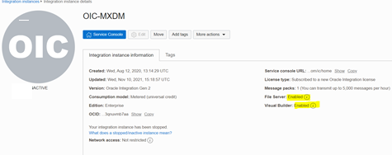

* Only one generic user for Fusion, OIC and FTP – Ex: **integration.user**.Unless specified by Client. This should be provisioned by Version1 Infrastructure Team.
* User **Integration.user** should have OIC Admin Access.
* Ensure Fusion User has the necessary roles to access BI reports and OIC Integration.
* Maximise Team needs access to Putty for Installing the tool.